**DAILY ONLINE ACTIVITIES SUMMARY**

|  |  |  |  |  |  |  |  |  |
| --- | --- | --- | --- | --- | --- | --- | --- | --- |
| **Date:** | **03-06-2020** | | | | | **Name:** | **Nachiketh S Bhat** | |
| **Sem & Sec** | **6th - B** | | | | | **USN:** | **4AL17CS119** | |
| **Online Test Summary** | | | | | | | | |
| **Subject** | | **PAP-III** | | | | | | |
| **Max. Marks** | | **20** | | **Score** | | | **17** | |
| **Certification Course Summary** | | | | | | | | |
| **Course** | **BLOCKCHAIN ESSENTIALS** | | | | | | | |
| **Certificate Provider** | | | **IBM** | | **Duration** | | | **Exam report** |
| **Coding Challenges** | | | | | | | | |
| **Problem Statemen: PYTHON PROGRAMS-8 JAVA-1** | | | | | | | | |
| **Status: executed** | | | | | | | | |
| **Uploaded the report in Github** | | | | | **yes** | | | |
| **If yes Repository name** | | | | | <https://github.com/nachi0106/Daily-Activity/tree/master/Online-coding%20report/03-05-20> | | | |
| **Uploaded the report in slack** | | | | | **Yes** | | | |

TEST DETAILS

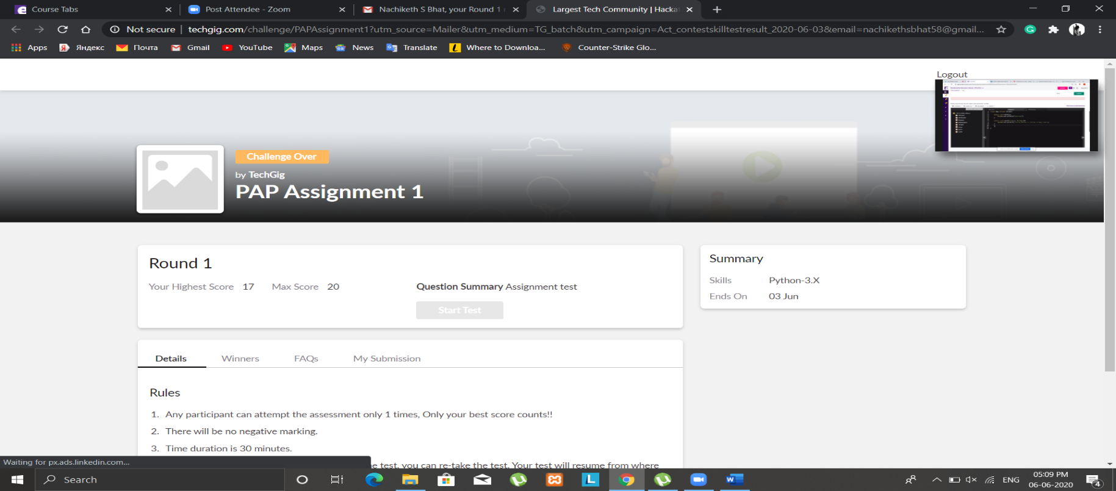

CERTIFICATION DETAILS

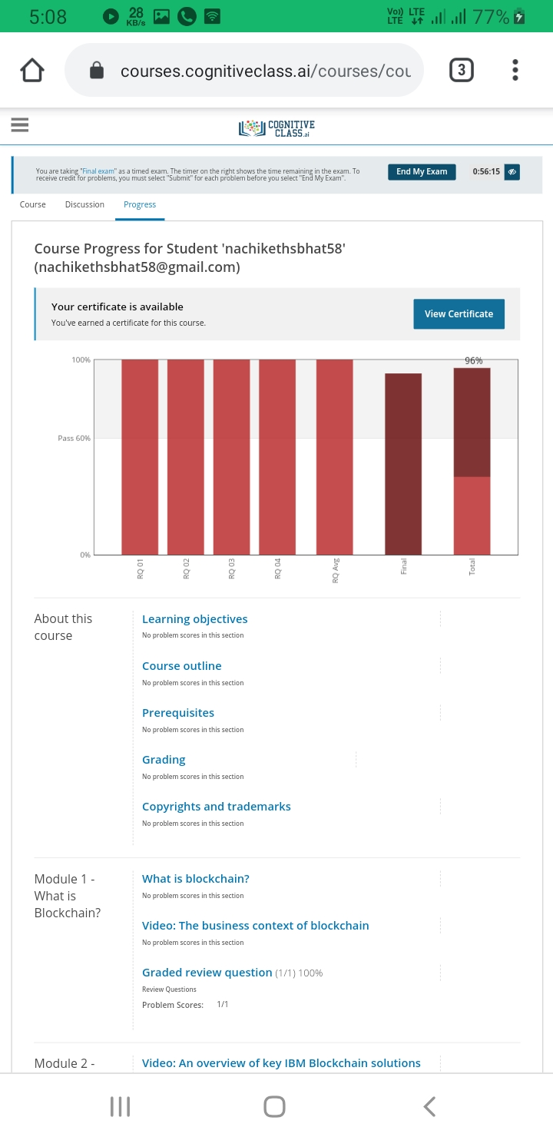

Badge

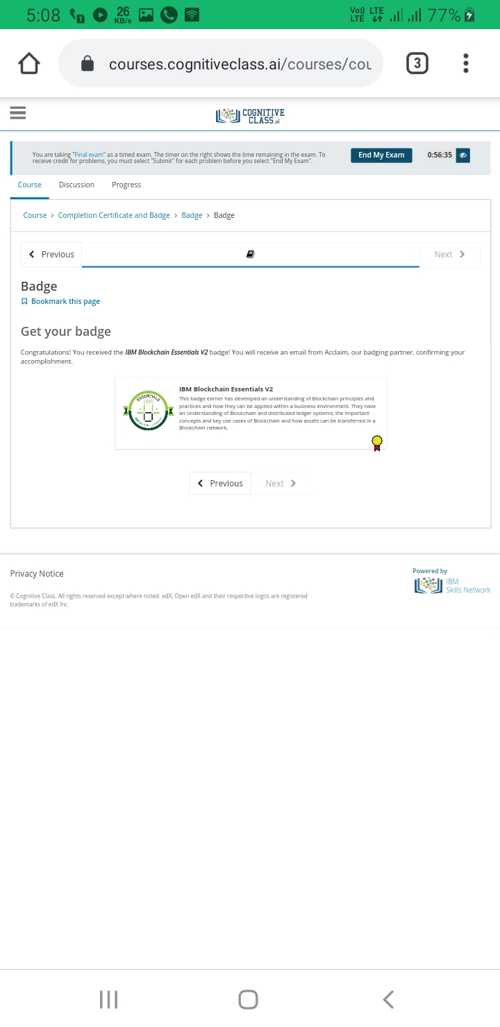

Certificate

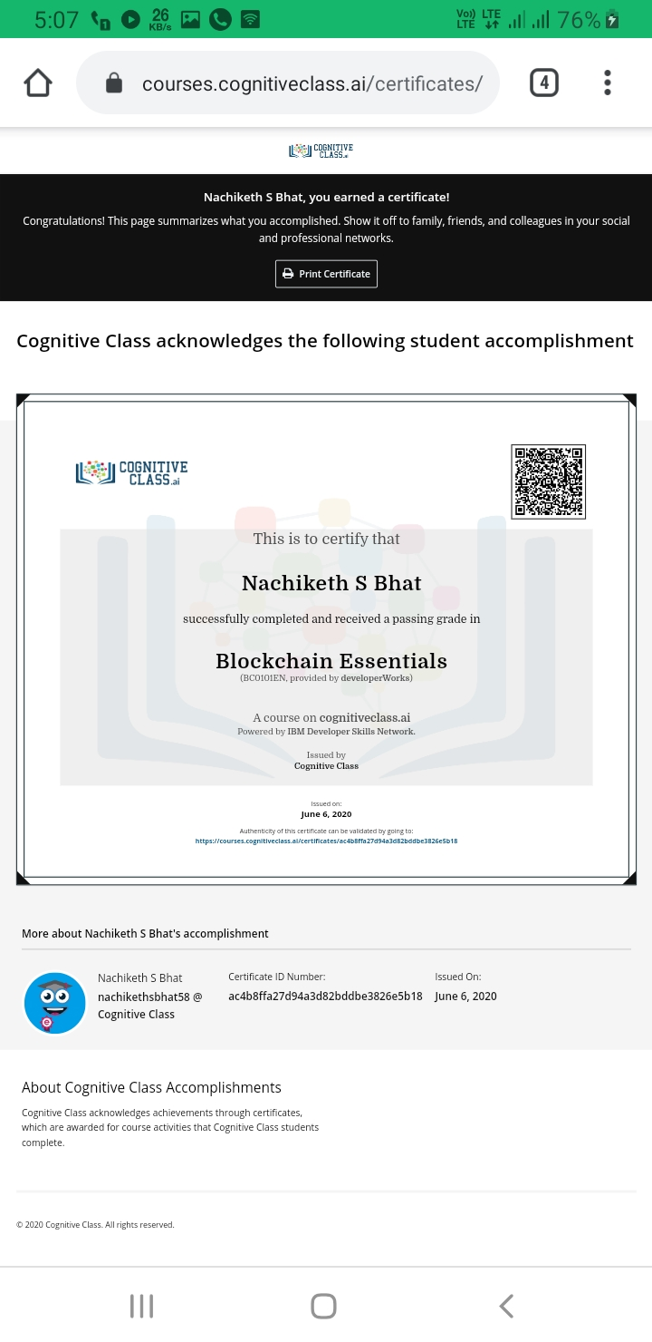

P-1

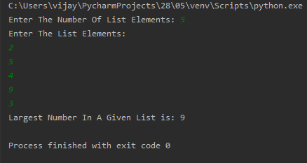

P-2

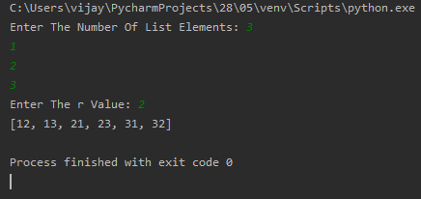

P-3

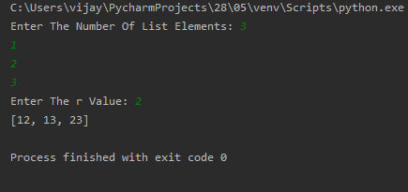

P-4

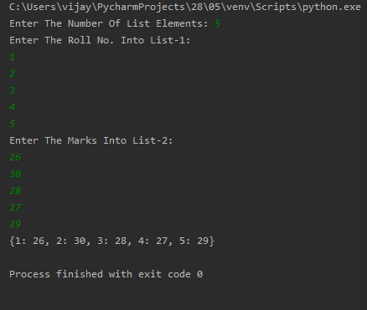

P-5

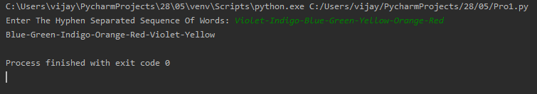

P-6

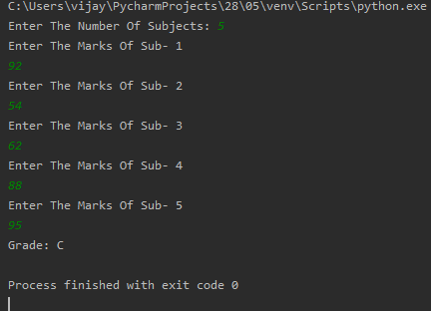

P-7

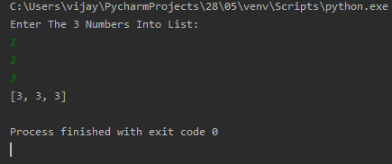

P-8

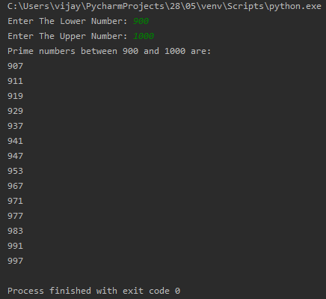

P-9

